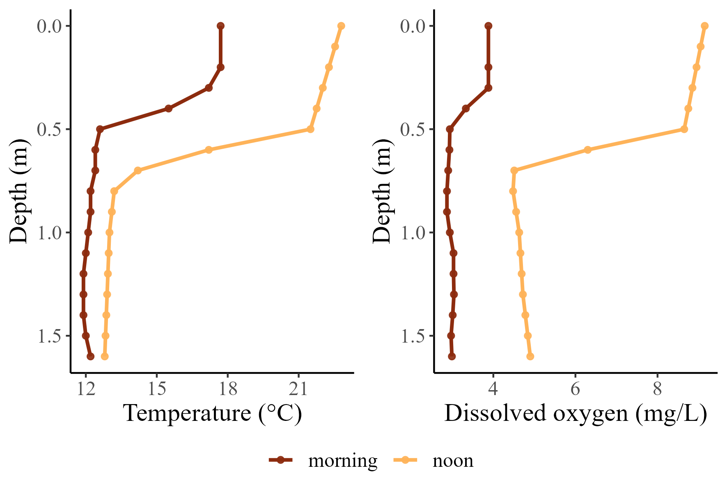
Figure 1. Diel contrasts in temperature and dissolved oxygen profiles for a floodplain alcove that provides thermal refuge for cold-water fishes of the Willamette River. Profiles were recorded at dawn (6:00, near DO-minima), and late afternoon (15:00, near the DO-maxima). Data are shown for the Blue Ruin alcove.

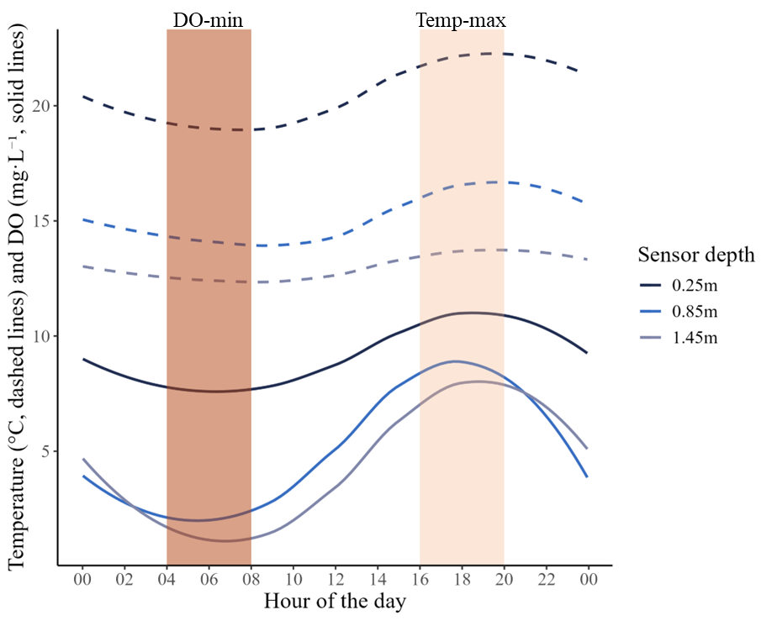
Figure 2. The diel cycle of water temperature and dissolved oxygen at three depths of a stratified floodplain alcove. Dashed lines represent temperature (°C), and solid lines represent dissolved oxygen (mg • L⁻¹). Shaded bars highlight the asynchrony between periods of peak hypoxia (dark pink) and peak thermal stress (light pink). Data shown here are for July 27th 2021 in Norwood alcove and have a 5-minute temporal resolution.

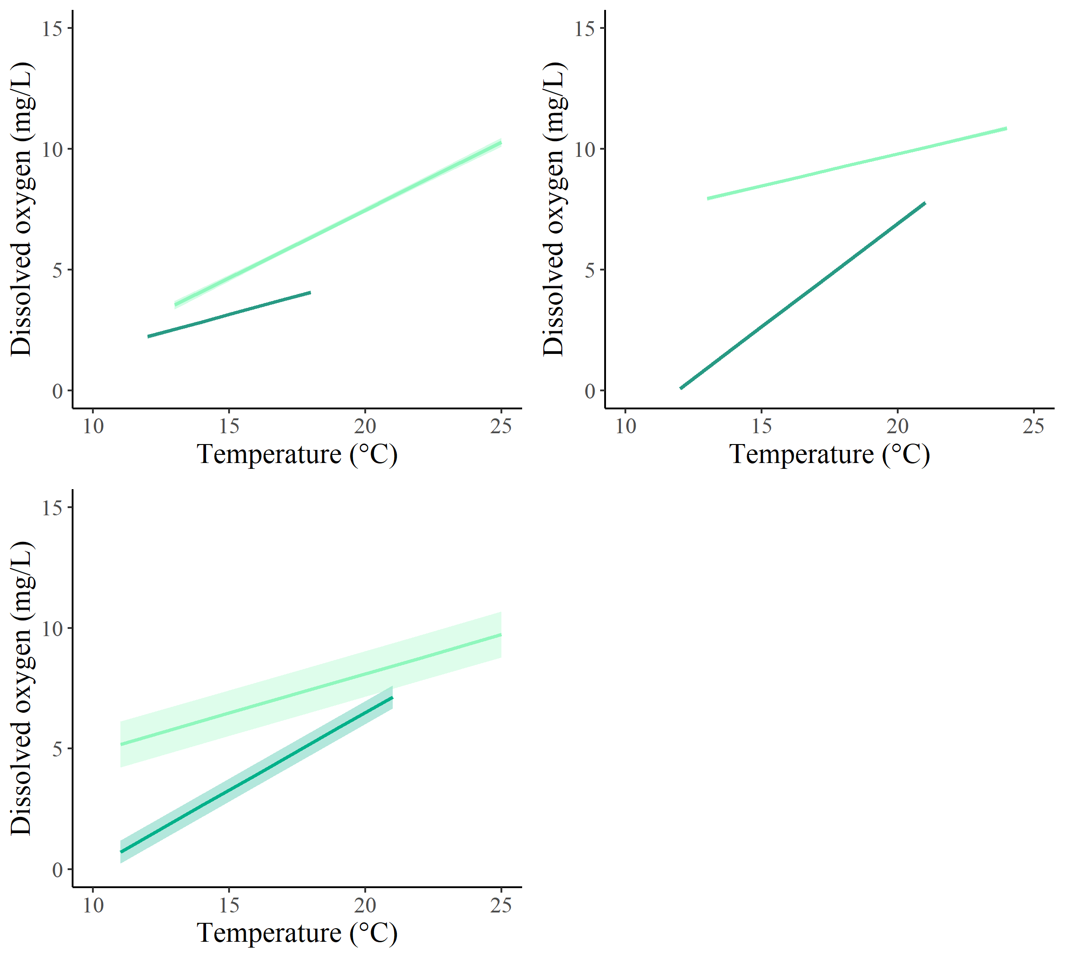
d
c
a
b
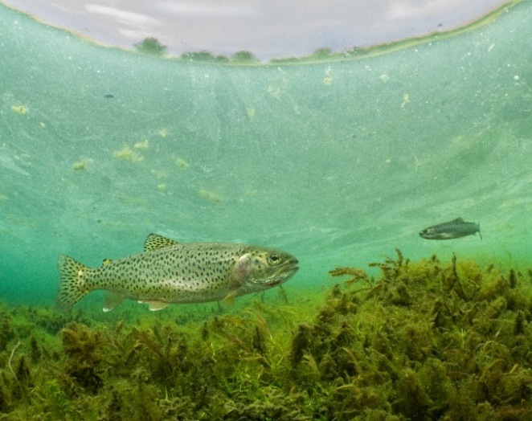
Figure 3. Results from linear mixed models evaluating the relationship between temperature and DO comparing the 2-hour window that approximates the DO-minima (dark green) to the 2-hour window that approximates the DO-maxima (light green) in a. Blue Ruin cold-water alcove, b. Norwood cold-water alcove, and c. all six cold-water alcoves. All linear fits are plotted with their 95% confidence interval envelopes. d. Photo of a coastal cutthroat trout in Blue Ruin cold-water alcove (photo credit: Dave Herasimtschuk, Freshwaters Illustrated).
b

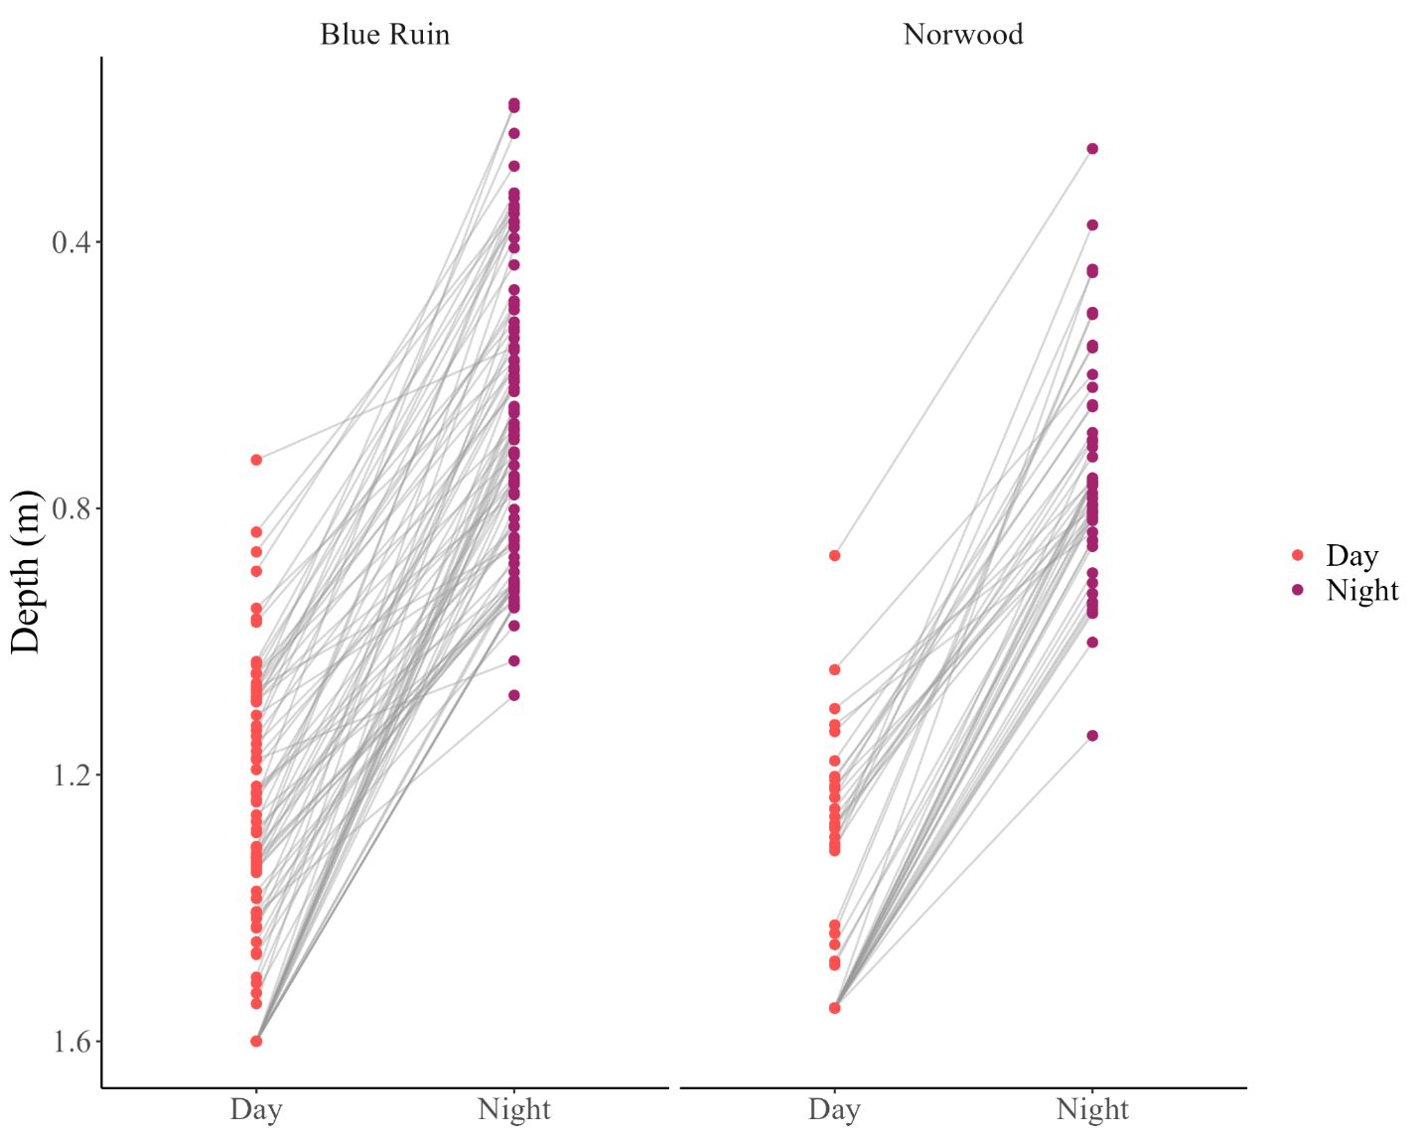
Figure 4. Diel changes in vertical position of tagged cutthroat trout for one week (July 30 – August 6). Each point represents the median depth of an individual fish during either day (red) or night (purple), and gray lines connect paired day-night values

b
a
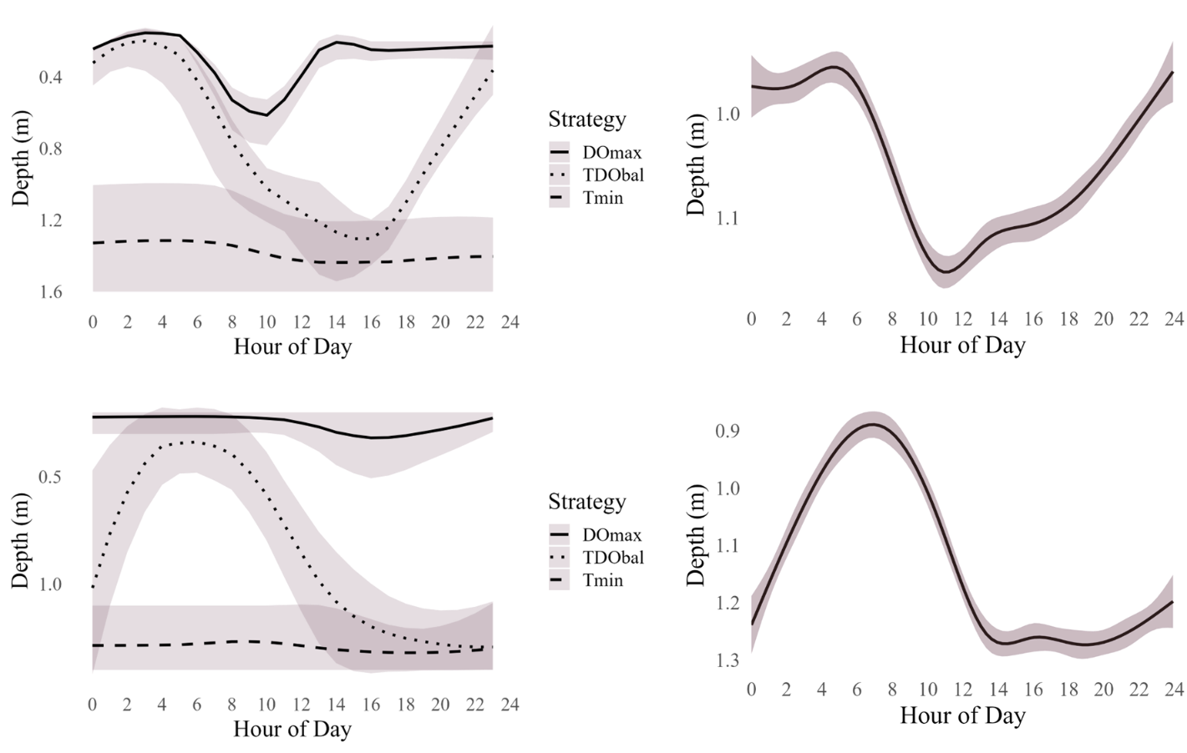
d
c
Figure 5. Depth selection behavior of cutthroat trout in Norwood and Blue Ruin alcoves across diel cycles. a. Conceptual simulation of fish depth over a 24-hour period at Norwood (August 1), based on three idealized behavioral strategies: maximizing dissolved oxygen (DOmax), minimizing water temperature (Tmin), or optimizing both concurrently (TDObal). b. Smoothed plot of observed diel vertical migration for tagged cutthroat trout at Norwood, pooled across individuals from August 1–7. c. Conceptual simulation of fish depth over a 24-hour period at Blue Ruin (August 1), using the same behavioral strategies. d. Smoothed plot of observed diel vertical migration for pooled iButton temperature data from Blue Ruin, August 1–7.

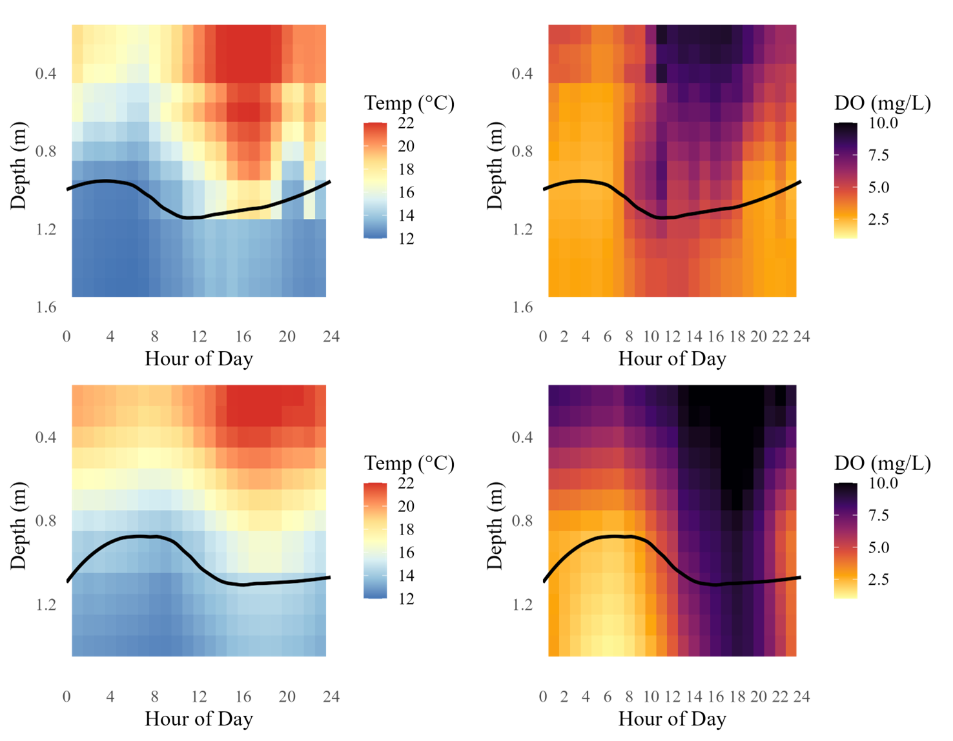
d
c
b
a
Figure 6. Temperature and dissolved oxygen (DO) profiles in relation to observed fish depth in Blue Ruin and Norwood alcoves. Color gradients represent hourly environmental conditions on August 1. Black lines indicate the smoothed depth of tagged cutthroat trout, pooled across individuals from August 1–7. a. Temperature profile in Blue Ruin. b. Dissolved oxygen profile in Blue Ruin. c. Temperature profile in Norwood. d. Dissolved oxygen profile in Norwood.

